Tode-RC
Product Overview

Pricing and Sales


http://www.TGit-Tech.com
Version: 232H
Last Updated: 2023-02-28

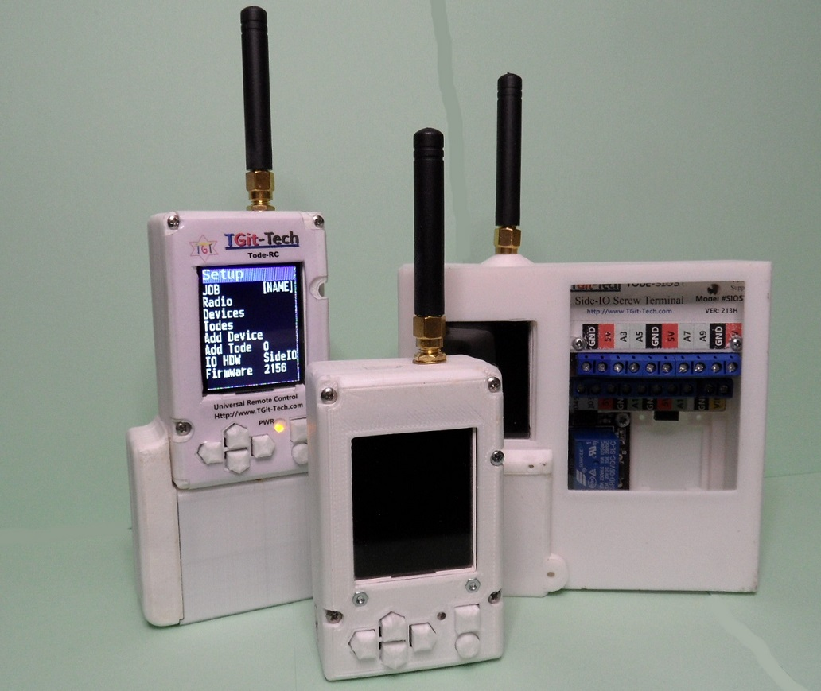

Table of Contents

Table of Contents
1. Table of Contents 2
2. Build Configurations 3
2.1 Options 3
2.2 Packages 4
3. Introduction 5

Descriptive Diagram

Build Configurations

The Tode System is licensed under the MIT License. It's hosted on Github.com at:
https://github.com/TGit-Tech/Tode-RC

Options

Face Options ( User Interface )
Part No. | Description  Design File Location or (not designed but planned) | Price
#TFT18AKB6 | 1.8” or 1.77” TFT LCD Screen  6-Key Analog Keypad  https://github.com/TGit-Tech/Tode-RC | $8.00
#TFT18DKB6 | 1.8” or 1.77” TFT LCD Screen  6-Key Digital Keypad ( an upgrade from analog )
#COVER | Not available at this time  A Cover Only
Tode Models (post-fix RC=Remote/Radio Control equipped)
#AMP | Arduino Mega Pro (AtMega2560)
#AMPE32T30 | Arduino Mega Pro (AtMega2560)  Ebyte E32-433T30D Radio (1W/30dbm)  https://github.com/TGit-Tech/Tode-RC | $31.00
#AMPE32T20 | Arduino Mega Pro (AtMega2560)  Ebyte E32-433T20D Radio (250mW/20dbm)
IO Stations
#SIOST | Side-IO Plug to Screw Terminals  https://github.com/TGit-Tech/Tode-SIOST | $15.00
Accessories
#DBL9VBATT | (2) 9Vdc Battery Tray | $4.00

Packages

Tode-RC Standard Build no Battery Tray |  |  | Total
#TFT18AKB6 | Supplies Cost | $8.00
#AMPE32T30 | Supplies Cost | $31.00
 | TOTAL Parts Cost | $47.00
 | Suggested Labor | $15.00 | $68.00
Tode-RC with a Battery Tray
#DBL9VBATT | Supplies Cost | $4.00
 | Suggested Labor | $1.00 | $73.00
SIOST IO-Station with a Tode-RC
#SIOST
Sellers Fee Costs
Ebay | 13.25% of bill + $0.30
Etsy | 6.5% sale & 4% transaction fee Totaling 10.5% of bill + $0.25
Tindie | 5% sale & 4% transaction fee  Totaling 9% of bill +$0.30
Shipping & Handling Costs

